Depthmap multiple merge

In order to multiple merge VGA points, open a graph and change to “join mode”:

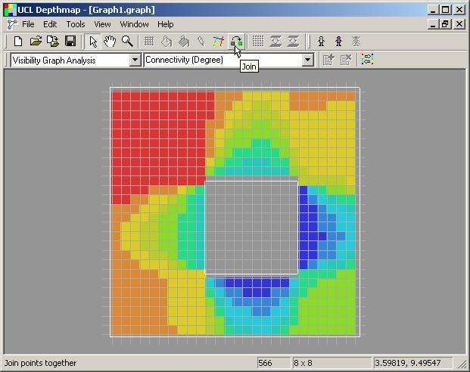

Then select a range of points by clicking and dragging with the mouse:

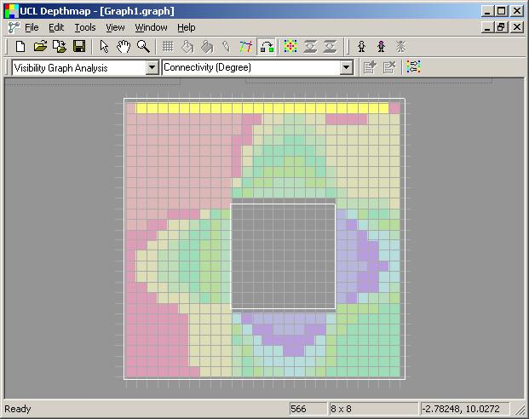

[continued on next page]
Next, move the mouse to the location where you want to join the set of points:

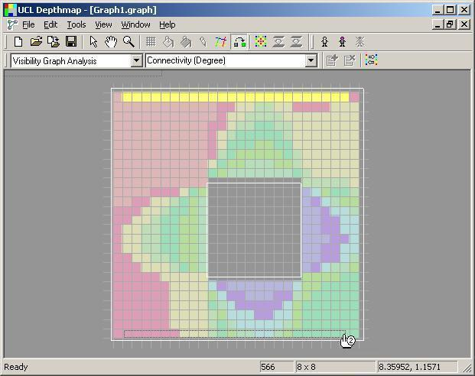

Then click to merge all the points simultaneously:

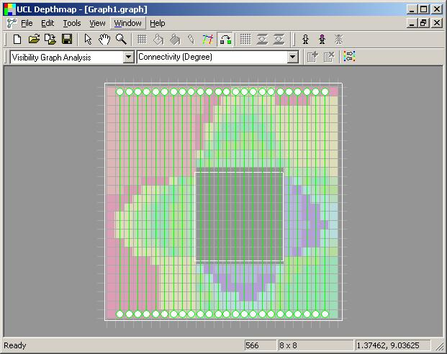

For a torus, I would suggest cross linking as shown:

